**Dawlance DW-162 HZP Microwave**

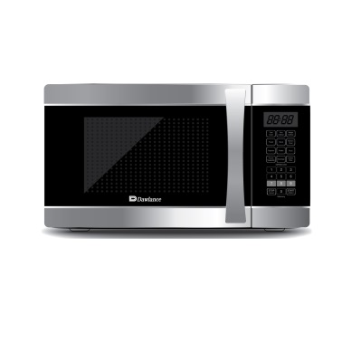

|  |  |
| --- | --- |
| **Capacity(litres):** | 62 |
| **Control System:** | Manual |
| **Grill:** | Yes |
| **Color:** | Silver |
| **Cavity:** | Painted |
| **Built-in Frame:** | No |
| **Net Width x Height x Depth:** | 621 x 499 x 346 |
| **Net Weight:** | 16 |
| **Nominal Power Microwave:** | 1000W |
| **Nominal Power grill:** | 1200W |
| **Microwave Power Levels:** | 4 |
| **Convection function:** | Yes |
| **Child Safely Lock:** | Yes |